2.AIM:-To implement UML diagrams for BANK BOOK PROCESS ..

1.USE CSE:-

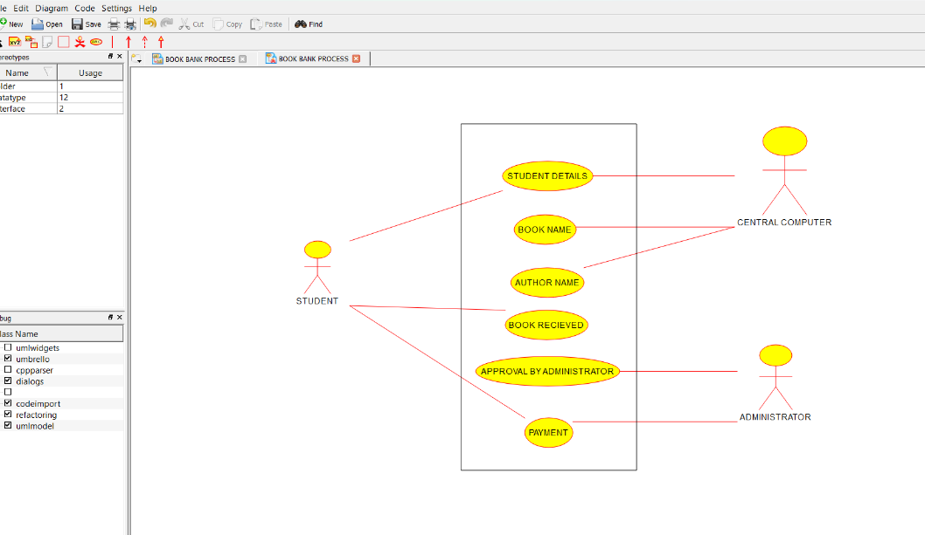

2.COLLABORATION DIAGRAM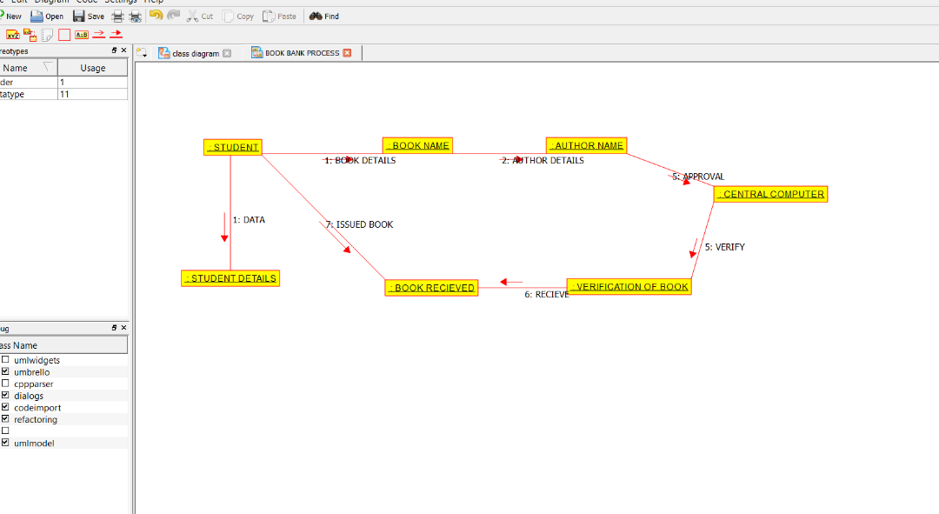

3.DEPLOYEMENT DIAGRAM

